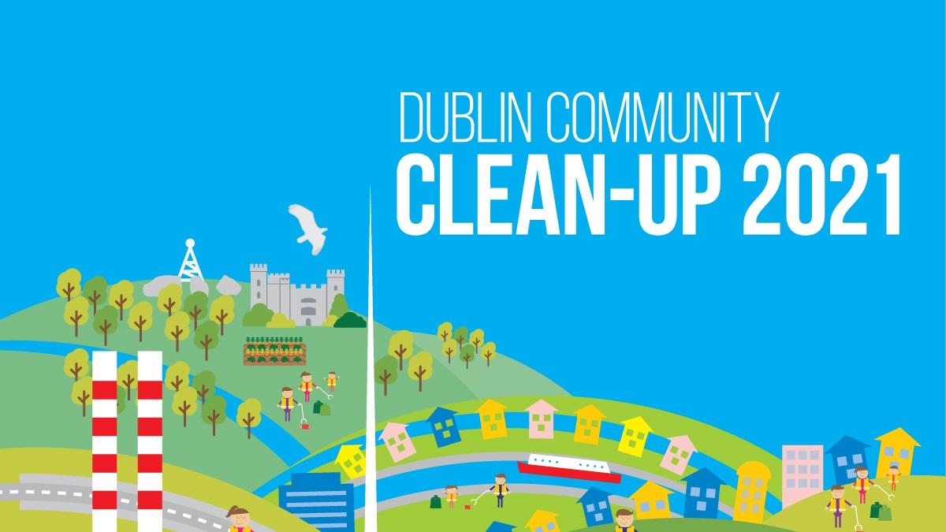
*Image for Twitter
Dublin Community Cleanup

In Dublin from the 11th to the 19 of September? Join us for the #dublincommunitycleanup. Help us #keepdublinbeautiful. Register here: https://dublincommunitycleanupday.ie/how-to-register/
Get the whole community involved. #ireland #litter #sourcetosea #Communities4Environment

Join us with your family and friends for the #dublincommunitycleanup. Together we can #keepdublinbeautiful. Follow this link to register: https://dublincommunitycleanupday.ie/how-to-register/ #dublin #ireland #Communities4Environment

Want to be part of #Dublin’s biggest #cleanup event? Register here https://dublincommunitycleanup.ie/how-to-register/ and be part of our mission to #keepdublinbeautiful #ireland #canals #streets #rivers #mountains #coast #Communities4Environment

A reminder that #Dublin’s biggest #cleanup event is taking place from the 11th to the 19th of September:. Join us and bring your family and friends! Let’s #dublincommunitycleanup Register online: https://dublincommunitycleanup.ie/how-to-register/
#ireland #litter #cleanup #community #Communities4Environment

#Dublin Community Clean Up is coming! It’s not too late to sign up and take this chance to #keepdublinbeautiful. It takes place from the 11th to the 19th of September: https://dublincommunitycleanup.ie/how-to-register/
#ireland #litter #sourcetosea #Communities4Environment
If you want to #keepdublinbeautiful register today for the biggest #Dublin Community Clean Up Day! Follow this link to register: https://dublincommunitycleanup.ie/how-to-register/
#dublin #ireland #canals #rivers #coast #streets #mountains #Communities4Environment

#Dublin biggest community #cleanup is taking this September. To join us, register here: https://dublincommunitycleanup.ie/how-to-register/
#dublncommunitycleanup #ireland #litterfree #sourcetosea #Communities4Environment

Stakeholders Twitter Handles
Fingal County Council
@Fingalcoco
Dun Laoghaire Rathdown
@dlrcc
South Dublin County Council
@sdublincoco
Dublin City Council Environment
@DubCityEnviro
Dodder Action
@DodderAction
Dublin Clean Canals
@DubCleanCanals
LA Waters Programme
@WatersProgramme
Clean Coasts
@CleanCoasts
National Spring Clean
@NationalSpringC
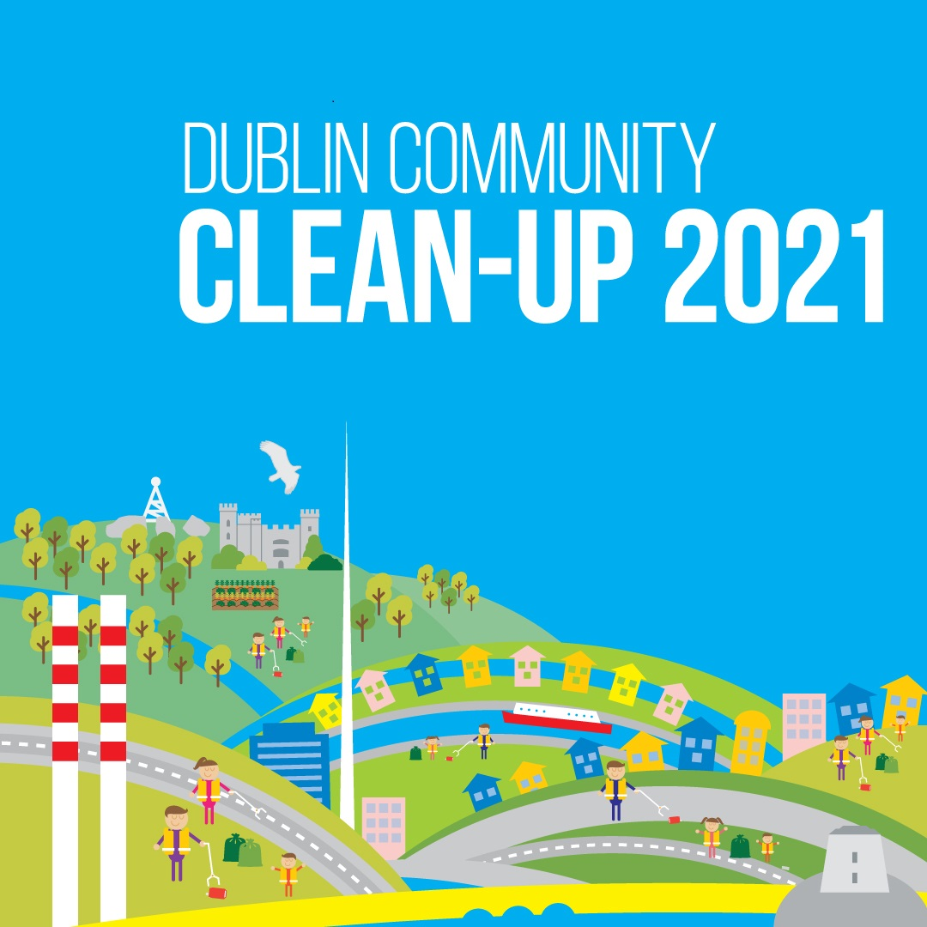
Image for Instagram

